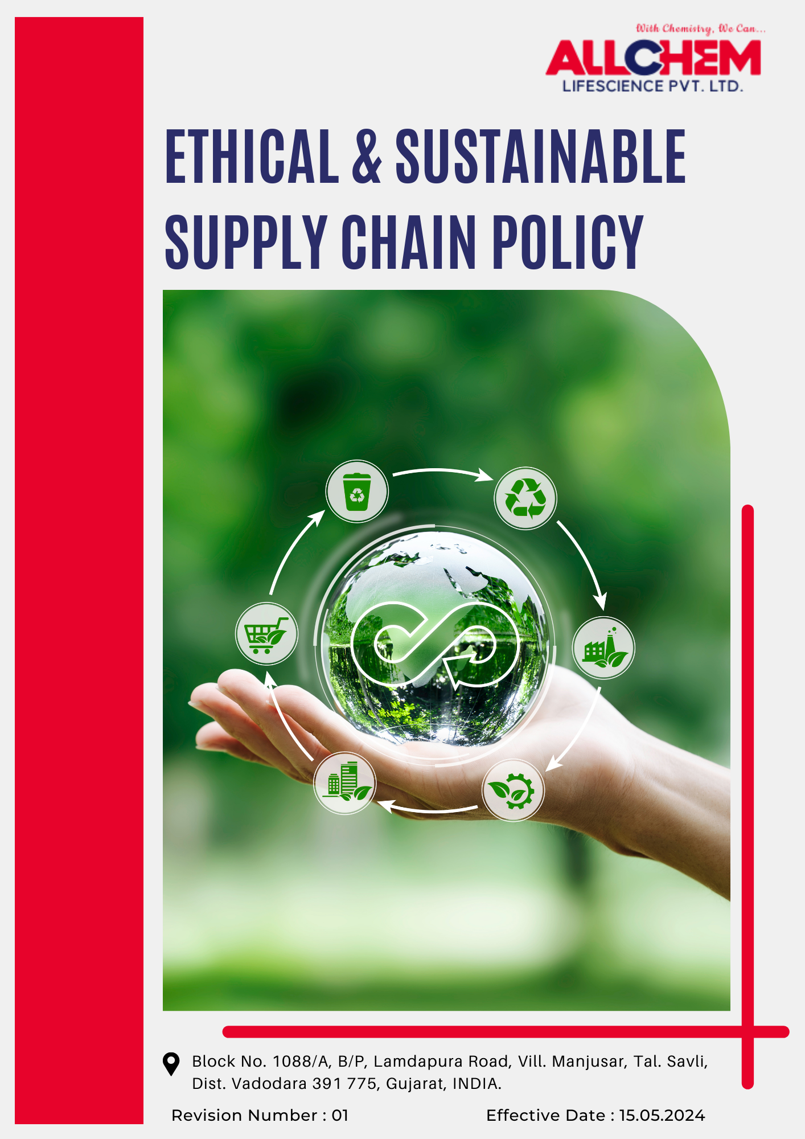

Contents
Preface 3
Scope 3
Policy Declaration 4
Key Action Areas 4
Targets based on our action areas 4
Our Targets in alignment with SDGs 6
Responsibilities 6
Review Mechanism 7
Employee Acknowledgement Form 8

Preface
Responsible sourcing and ethical business conduct define supply chain operations at Allchem Lifescience Pvt. Ltd. Supplier partnerships are built on transparency, fair labor practices, environmental stewardship, and strict compliance with legal and ethical standards.
This policy outlines expectations for sustainable procurement, human rights protection, anti-corruption measures, and environmental impact management. Strengthening due diligence, risk assessments, and continuous monitoring ensures that supply chain practices align with global sustainability goals and regulatory frameworks.
Collaboration with suppliers, regular evaluations, and proactive risk mitigation drive ethical and sustainable growth while reinforcing long-term business integrity.
Scope
This policy governs all procurement and sourcing activities across Allchem Lifescience Pvt. Ltd.'s operations, manufacturing sites, and supply chains, ensuring adherence to ethical and sustainable practices. It applies to employees, suppliers, contractors, and business partners engaged in sourcing, procurement, and material handling processes.
Allchem Lifescience Pvt. Ltd. | Block No. 1088/A, B/P, Lamdapura Road, Vill. Manjusar, Tal.-Savli, Dist.-Vadodara -391 775, Gujarat, India.

Policy Declaration
Allchem Lifescience Pvt. Ltd. upholds responsible sourcing by emphasizing ethical procurement, supplier accountability, and sustainable material selection. With Year 2022 as the baseline, sourcing decisions are based on transparency, fair labor standards, and environmental responsibility. Continuous improvements are achieved through supplier engagement, risk evaluations, and collaboration with industry partners to uphold integrity across the supply chain.
Key Action Areas
- Suppliers must adhere to stringent environmental regulations, minimize emissions, reduce waste, and implement resource-efficient processes. Preference to be given to suppliers with certifications in sustainable production and environmental management.
- Business partners must uphold fair labor practices, safe working conditions, and human rights in line with international standards. Suppliers are expected to maintain zero forced labor, child labor, and discrimination while promoting workplace diversity and fair wages.
- Source palm oil and palm-derived products only from certified sustainable sources, ensuring legality, traceability, and environmental responsibility.
- Mandate adherence to responsible sourcing guidelines through supplier audits, certifications, and performance evaluations.
- Partnerships to be formed with suppliers that prioritize low-carbon manufacturing, renewable energy integration, and reduced transportation emissions.
- Engage with stakeholders, industry groups, and regulatory bodies to enhance supply chain transparency and responsible procurement practices.
Targets based on our action areas
- Responsible Procurement of Raw Materials
- Ensure all high-impact raw materials, including chemicals and solvents, meet recognized environmental and safety standards by year 2028.
- Establish a supplier monitoring framework to assess compliance with material sustainability guidelines.
- Source 75% of key raw materials from certified sustainable or recycled sources by year 2028.

- Environmental Responsibility in Supplier Operations
- Ensure 50% of key suppliers adopt ISO 14001 or equivalent environmental management systems by year 2028.
- Reduce supply chain-related carbon emissions by 20% by year 2028 through energy-efficient, low-emission, and locally sourced materials.
- Establish long-term partnerships with suppliers committed to ethical and sustainable practices.
- Implement a supplier sustainability rating system to assess and improve supplier performance in responsible sourcing, incorporating incentives such as priority contracts or long-term partnerships for high-performing suppliers.
- Organize annual training sessions for 100% of Allchem Lifescience’s key suppliers on sustainable sourcing practices and environmental compliance.

- Ethical Labor Practices and Human Rights in Supply Chain
- Ensure that 100% of direct suppliers comply with fair labor practices, workplace safety regulations, and human rights standards through comprehensive supplier audits by year 2028.
- Train 100% procurement staff and key suppliers on ethical sourcing, labor rights, and responsible supply chain management.
- Ensure 100% of suppliers have policies and controls in place to maintain cases of forced labor, child labor, and workplace exploitation.
- Ensure all direct suppliers to provide wages that meet or exceed living wage standards.

- Sustainable Sourcing of Palm Oil and Palm-Based Materials
- Source 100% of palm oil and palm-based derivatives from RSPO-certified sustainable suppliers by year 2028.
- Enhance transparency in the Palm oil supply chain by requiring suppliers to disclose sourcing origins and sustainability certifications.
- Engage with suppliers to promote best practices in palm oil procurement, including environmental conservation and Indigenous rights protection.
- Identify and integrate sustainable alternatives to palm oil in key products, reducing palm-based material usage by 10% by year 2028.
- Phase out procurement from suppliers linked to deforestation, habitat destruction, or labor rights violations by year 2028.
Our Targets in alignment with SDGs
- SDG 8: Decent Work and Economic Growth – Ensuring fair wages, eliminating child and forced labor, and protecting workers' rights.
- SDG 10: Reduced Inequalities – Ensuring equal opportunities and reducing workplace discrimination.
- SDG 12: Responsible Consumption and Production – Encouraging sustainable resource use, procurement, and waste reduction in supply chains.
- SDG 13: Climate Action – Reducing supply chain-related carbon emissions and promoting environmental responsibility.
- SDG 15: Life on Land – Preventing deforestation and biodiversity loss through sustainable sourcing of raw materials, including palm oil.
- SDG 17: Partnerships for the Goals – Strengthening collaborations for responsible procurement and ethical supplier engagement.
Responsibilities
- The Procurement Team ensures compliance with ethical and sustainable sourcing standards, evaluates supplier performance, and integrates sustainability criteria into procurement decisions.
- The Sustainability Team monitors environmental and social impacts within the supply chain, engages suppliers on best practices, and drives continuous improvement initiatives.
- The Compliance Team conducts audits, verifies supplier adherence to regulatory and company-specific requirements, and addresses non-compliance through corrective actions.
- Senior Management oversees policy implementation, approves strategic sourcing decisions, and ensures alignment with corporate sustainability goals.
Review Mechanism
- The Procurement Head reviews this policy biennially or earlier if required due to regulatory changes, emerging risks, or evolving business needs.
- The review process includes an evaluation of supplier assessments, internal audits, stakeholder feedback, and industry developments to ensure the policy remains effective and aligned with best practices.
- Necessary revisions are incorporated to strengthen enforcement measures, enhance supplier accountability, and address identified gaps.
- Updated policies are communicated to employees, suppliers, and relevant stakeholders through structured training, awareness programs, and official notifications to ensure continued compliance and alignment with sustainability objectives.

Effective Date | : 15.05.2024
Next Review Date | : 15.05.2026
Approved By | :

Employee Acknowledgement Form
I acknowledge that I have received, read, and understood the Ethical and Sustainable Supply Chain Policy of Allchem Lifescience Pvt. Ltd. I agree to adhere to the principles outlined in this policy, including ethical procurement, sustainable sourcing, supplier accountability, and responsible business conduct.
I recognize my responsibility to uphold this policy in all procurement and supply chain activities and to report any concerns or violations through designated channels. I understand that non-compliance may result in disciplinary action as per company regulations.
By signing this acknowledgment, I confirm my commitment to ethical, sustainable, and responsible sourcing practices in alignment with Allchem Lifescience Pvt. Ltd.’s standards.
Employee Name  Employee ID  Date  Signature | :_______________________________  :_______________________________ :________________________________  : _______________________________

